This Christian Easter game makes it fun and easy to teach kids the true meaning of Easter!

How Does the Resurrection Tree Activity Teach Kids About Easter?
Engage kids in meaningful discussion about the true Easter story as they hang a new card on the Resurrection Tree each day and learn more about Easter with this simple lesson about the Resurrection (script included for parents).
Children create a “tree” from tree branches placed in a vase. Then using the 12 Easter Resurrection Tree Mini Cards (copied from the Christ Centered Easter Family Resources), children hang one card on the tree for 12 days.
Each mini card symbolizes one of 12 different Easter gifts and contains a Bible verse reference to that topic:

- peace
- power
- love
- unity
- new creation
- grace
- sacrifice
- resurrection
- forgiveness
- rebirth
- joy

Each day, parents and kids discuss that gift’s meaning by reading the Bible verse and talking about it together.
Putting together a Resurrection Tree as part of your family’s Resurrection lessons for kids is easy!
Here’s what you need to put together your own Resurrection Tree, along with the step- by- step instructions.

Resurrection Tree Supplies:
- Vase
- Tree branches
- twine or jute (12 pieces, each approximately 6 inches long)
- Bible
- laminator (optional)
- single hole punch
- 12 Easter Resurrection Tree Mini Cards

Resurrection Tree Instructions:
Step 1: Print out the 12 Easter Resurrection Tree Mini Cards and cut them out. You can laminate the Resurrection Tree Mini Cards for extra durability if you’d like.
Step 2: Hole punch the cards and string the jute through the holes.
Step 3: Gather a bunch of tree branches with a few leaves on them and place them in a vase with water.
Each day kids hang one of the Christ Centered Easter Resurrection Tree Mini Cards (each representing a special gift God gives us at Easter) on the tree.
Then, together, parents and kids look up a corresponding Bible verse about the word and discuss it together.
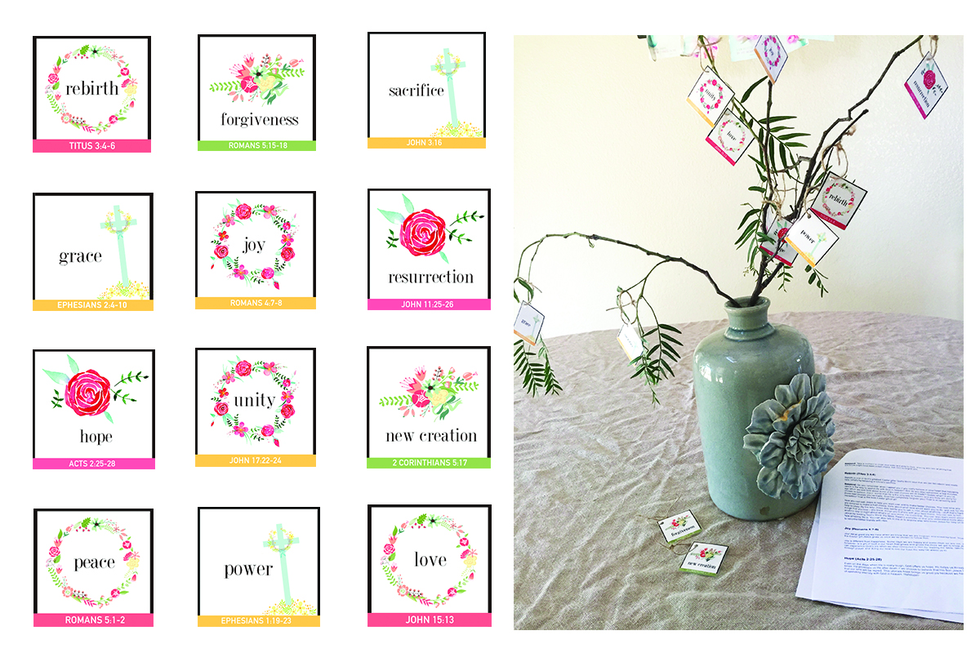

Taken from: https://christcenteredholidays.com/how-to-make-a-resurrection-tree/
About the Author- Alicia Michelle
As a wife and mom to four passionate kids, Alicia Michelle loves encouraging women, married couples, and families with practical tips for growing closer to God during holidays like Easter, Christmas, and Thanksgiving. Alicia is the owner/editor of both ChristCenteredHolidays.com and YourVibrantFamily.com; the author of Plan to Be Flexible, The Back- to- School Survival Manual; and the creator/producer of the "7 Days to a Less Angry Mom Online Video Course,", Christ-Centered Christmas Resources and My Memory Box Organizing System. In addition, she is a monthly contributor for several popular family blogs, including Crosswalk.com. Follow her on Facebook, Twitter, Instagram, and Pinterest.

