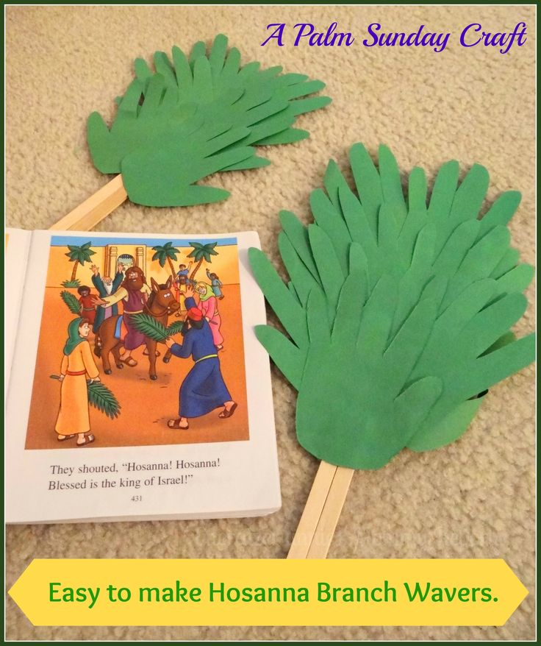
Step 1: Trace children’s hands on to green construction paper. Make as many as your children want to hold.
Step 2: Cut out traced hands and glue each to a popsicle stick.
Step 3: Write Hosanna on each stick.
Optional- Have your own Palm parade through your house.

