[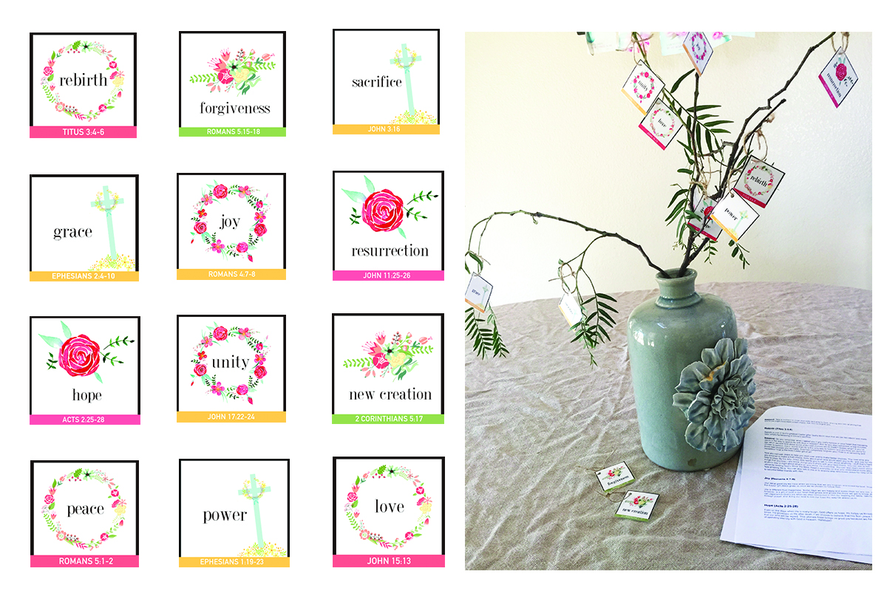](https://christcenteredholidays.com/christ-centered-easter-family-resources/)